CREATING A SERVICE INSTANCE

* First, Register and Login in your IBM cloud Account.
* Click on Catalog.
* Type Cloudant in the Search bar and Click on Open it.
* Select an Offering and an environment.
* Select region as Dallas and Type an instance name then click on create service.
* After you click create the system displays a message to say that the instance is being provisioned, which returns you to the Resource list. From the Resource list, you see that the status for your instance is, Provision in Progress.
* When the status changes to active, click the instance.

**Creating the IBM Cloudant service**

IBM Cloudant uses resource groups for provisioning new instances rather than Cloud Foundry orgs and spaces. IBM Cloudant instances that were provisioned in the past can still be deployed in Cloud Foundry orgs and spaces.

ibmcloud resource service-instance-create NAME SERVICE_NAME SERVICE_PLAN_NAME LOCATION [-p, --parameters @JSON_FILE | JSON_STRING ]

The fields in the command are described in the table that follows.

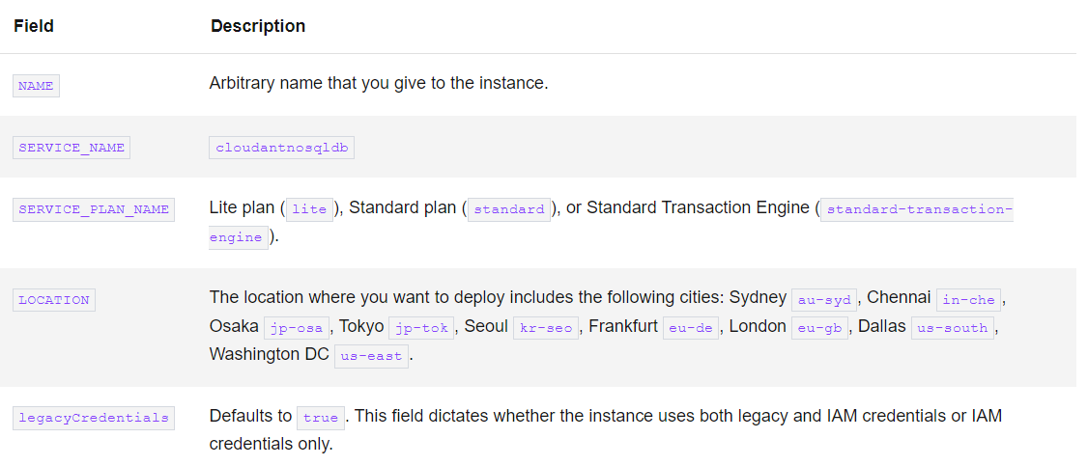

**Create a service instance and bind it to your application.**

Confirm you have access to create a service instance. Run the following command to view a list of enabled services. If you do not have access, contact your cluster administrator.

cf marketplace

Provision a service by creating a service instance:

cf create-service <service-name> <service-plan> <your-service-instance-name>

Bind the service instance to your application by using this command:

cf bind-service <application-name> <service-instance-name>